Azure Virtual Machine

Pranav Ram K S

Step 1 : Log in to the Azure portal

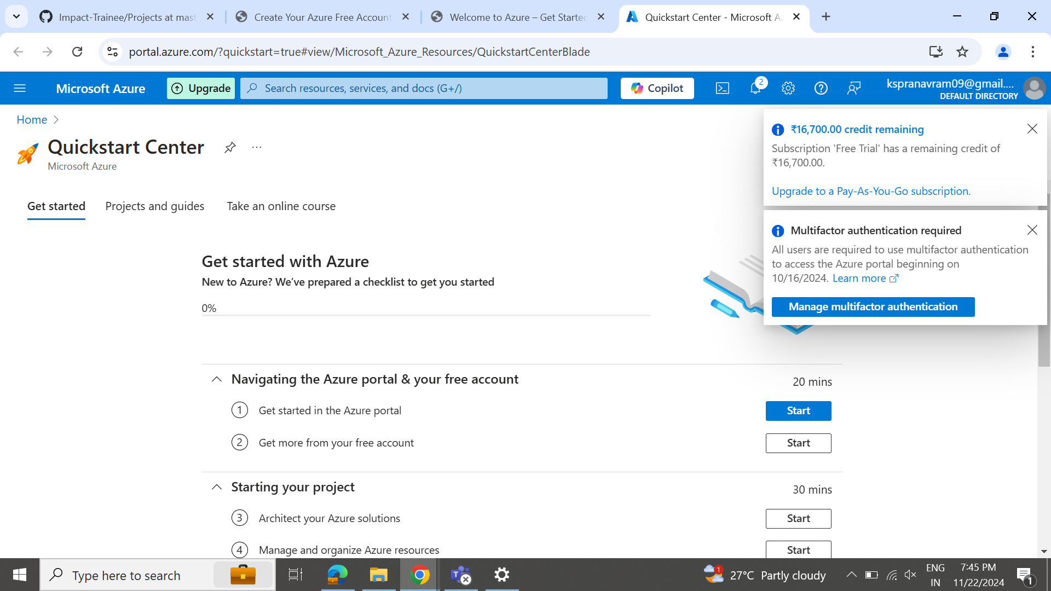

Step 2: Select Virtual machine.

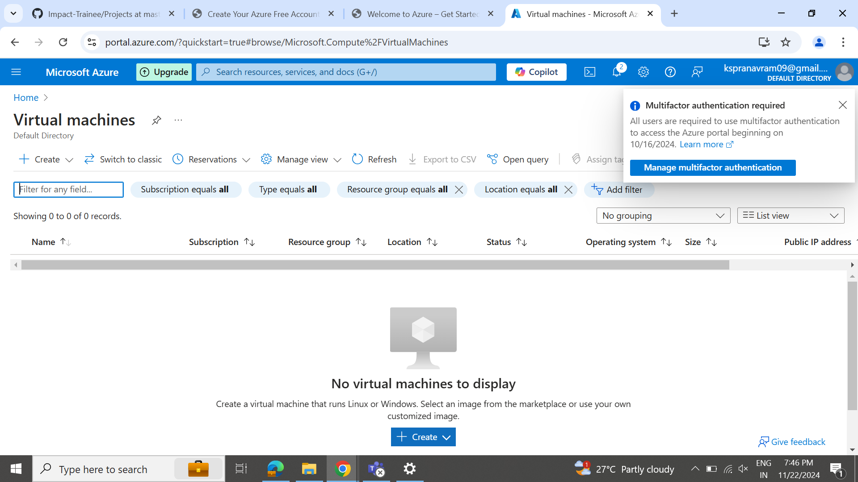

Step 3: create a resource group.

Step 4: Provide a name for the resource group and select a region

Step 5: Give your virtual machine a name.

Step 6: Choose a region for the virtual machine

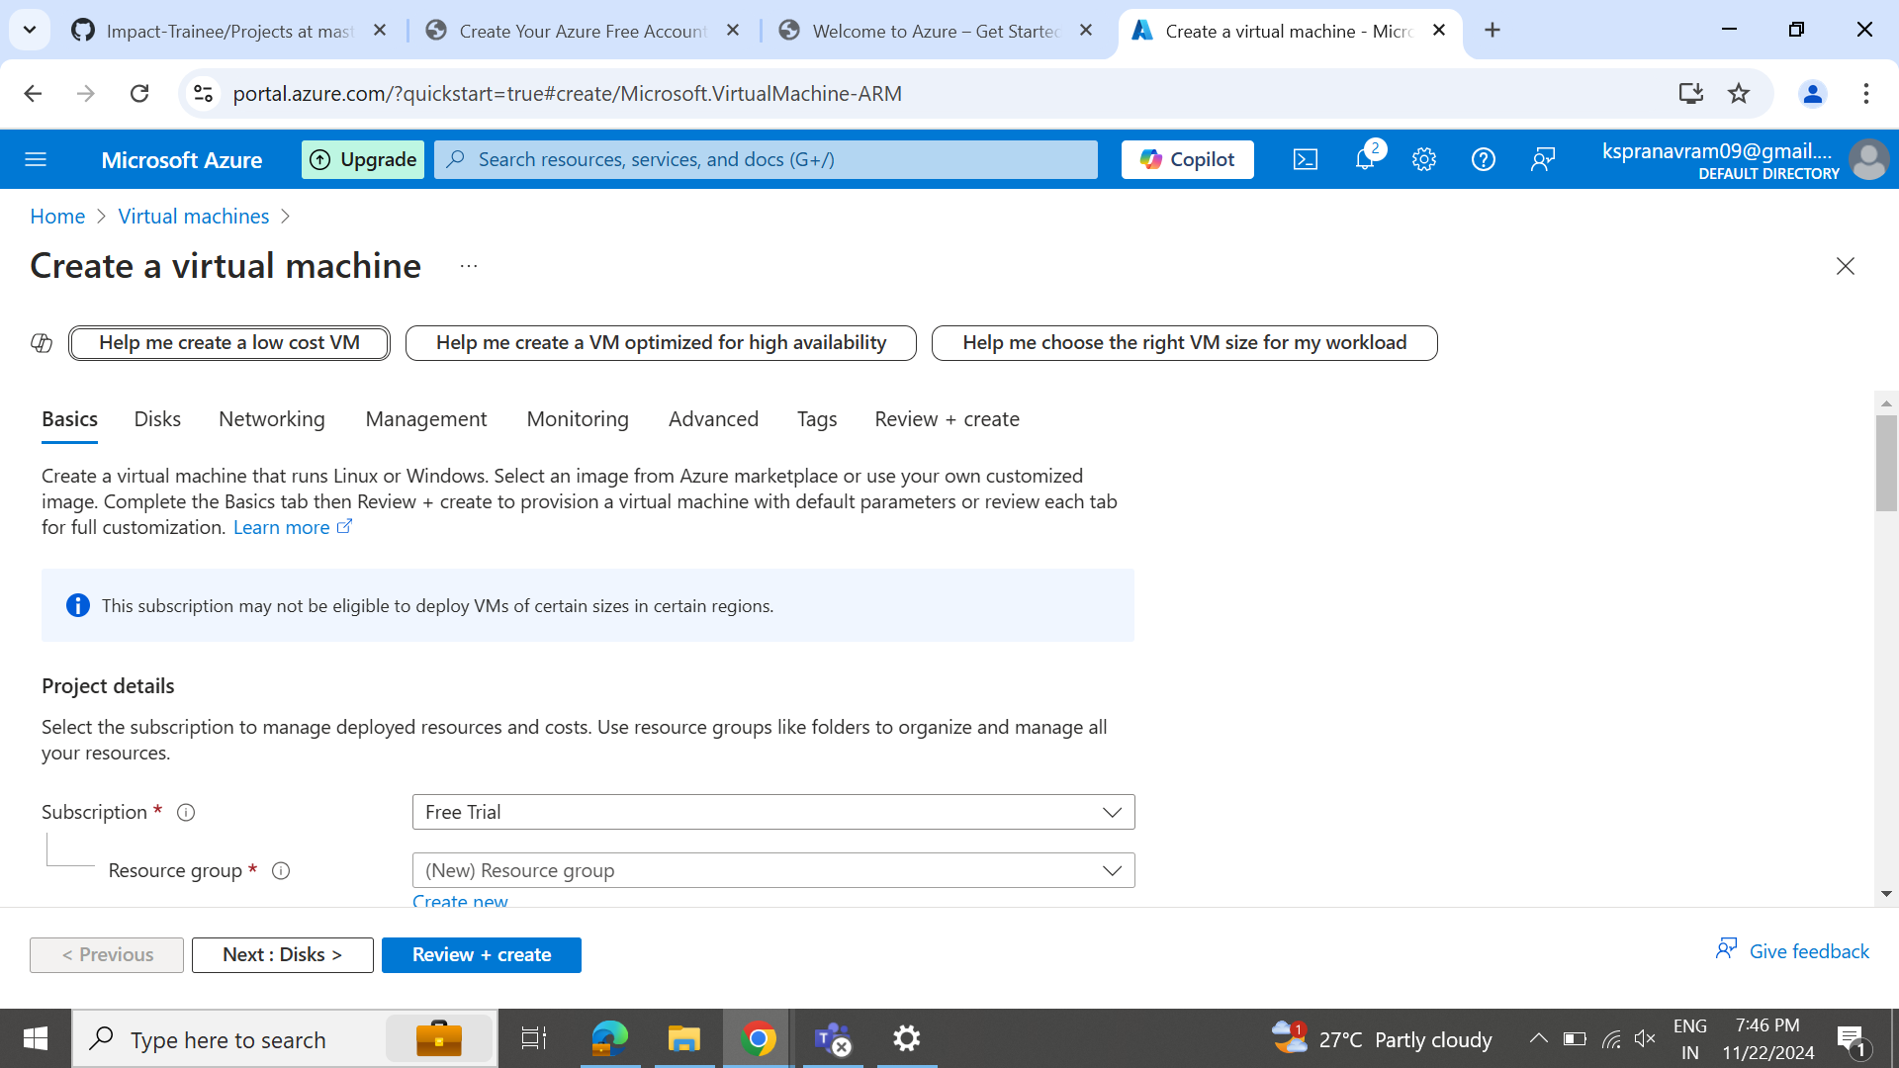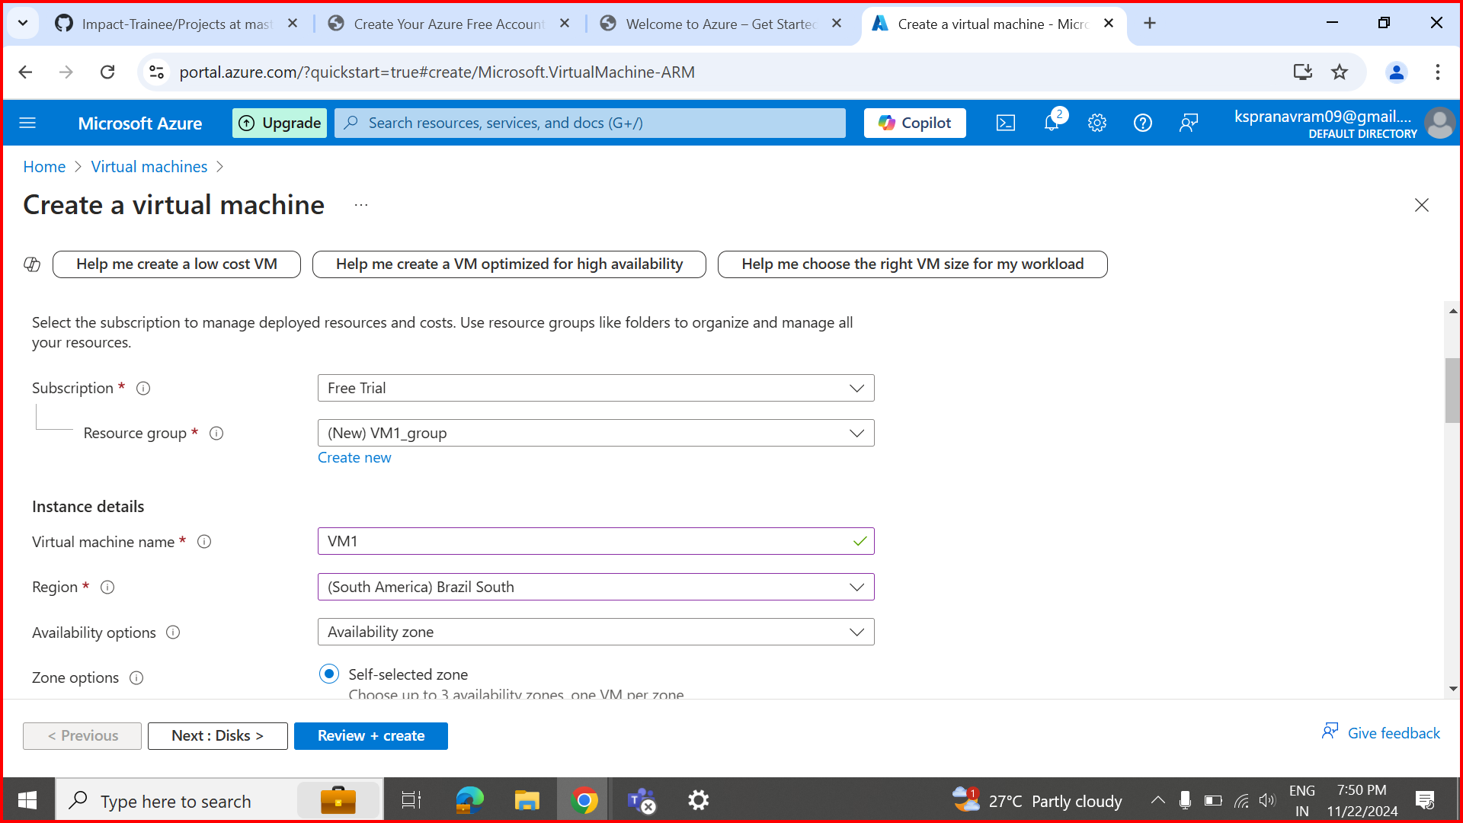

Step 7: Follow and customize the resources as per the requirement

Step 8: Review the virtual machine configuration and click "Create" to deploy the virtual machine.

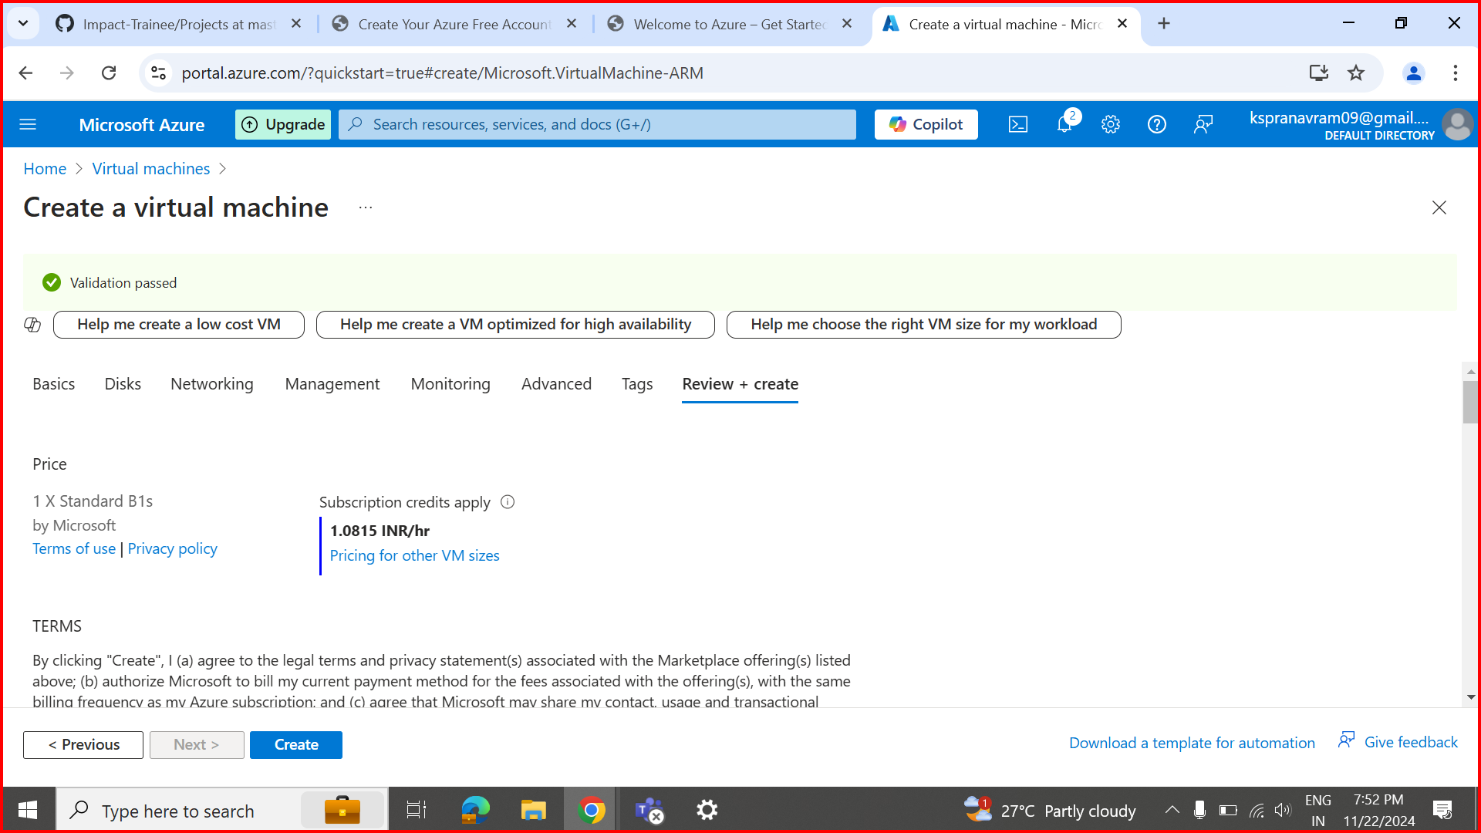

Step 9: Create and download key pair.

Step 10: Click the create button to deploy the Virtual machine.

